Taylor Posey

CSE 373 A

11/02/14

**Assignment 4 Part 1**

1. Suppose the following are companies that start off as small startups: Acme, Biocybo, CryoBio, DigiToe, Exxoff, Fibon, GIGO, Hashco, iWin, and Junkium. The following sequence of corporate mergers take place, and in each case, the new entity adopts the name of that smaller company whose name was closer to the beginning of the alphabetical list. For example, if iWin and Junkium merge, the new company's name is iWin. The merge operations are called UNION. Identifying the new company to which the original employees of an old company C work is called FIND.

(a). Suppose that the following operations are performed in sequence. Give the results of each FIND operation. No answer is required for UNION operations.

1. UNION Biocybo, CryoBio
2. FIND Biocybo **(answer: Biocybo)**
3. FIND CryoBio **(answer: Biocybo)**
4. UNION Junkium, Digitoe
5. UNION Acme, Digitoe
6. FIND Exxoff **(answer: Exxoff)**
7. FIND Junkium **(answer: Acme)**
8. UNION Fibon, Hashco
9. UNION iWin, Biocybo
10. FIND Hashco **(answer: Fibon)**
11. FIND iWin **(answer: Biocybo)**
12. UNION Fibon, Biocybo
13. FIND Hashco **(answer: Biocybo)**
14. UNION Biocybo, Acme
15. FIND CryoBio **(answer: Acme)**

(b). Now draw the forest of up-trees that result from these operations.

Acme Biocybo CryoBio

DigiToe Exxoff Fibon

GIGO Hashco iWin Junkium

2. Consider the following set of vertices, analogous to that above. Here, instead of corporate names, each vertex is identified by an (x, y) coordinate pair.

(a). Once again, show the results for the FIND operations, but use this new set of items and the following sequence. Assume that a UNION (x0,y0), (x1,y1) operation leads to a subset of name (x0,y0) if either (x0 < x1) or (x0 = x1 and y0 < y1), and to a subset of name (x1,y1) otherwise. Also, let us define a new operation FIND_UNION A, B to be equivalent to UNION FIND(A), FIND(B).

1. FIND (2,1) **(answer: (2,1))**
2. FIND_UNION (1,2), (2,2)
3. FIND_UNION (1,1), (2,1)
4. FIND_UNION (3,2), (3,3)
5. FIND_UNION (1,3), (2,3)
6. FIND (3,3) **(answer: (3,2))**
7. FIND (2,3) **(answer: (1,3))**
8. FIND_UNION (3,1), (3,0)
9. FIND_UNION (3,2), (3,1)
10. FIND (3,3) **(answer: (3,0))**
11. FIND_UNION (0,3), (1,3)
12. FIND_UNION (0,1), (0,2)
13. FIND (1,3) **(answer: (0,3))**
14. FIND_UNION (1,0), (2,0)
15. FIND_UNION (0,3), (0,2)
16. FIND (2,3) **(answer: (0,1))**
17. FIND_UNION (0,0), (0,1)
18. FIND (1,3) **(answer: (0,0))**
19. FIND (1,2) **(answer: (1,2))**
20. FIND_UNION (2,2), (3,2)
21. FIND_UNION (2,0), (3,0)
22. FIND (3,3) **(answer: (1,2))**
23. FIND (1,1) **(answer: (1,1))**

(b). Now draw the forest of up-trees that result from the operations.

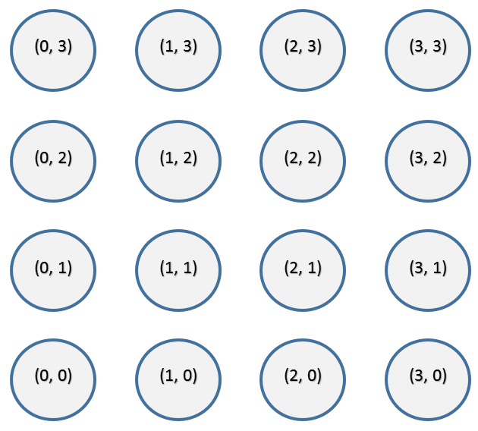

3. We define the *strict pixel graph* of an image to be the pair Gs = (V, E), where V is the set of pixels, like those shown above in the diagram for the previous exercise. Then E is the set of edges, where an edge e connects v0 = (x0, y0) with v1 = (x1, y1) provided | x0 - x1 | + | y0 - y1 | = 1 and the colors of the two pixels are equal.

(a). Draw the strict pixel graph on top of the copy of the image. The edges should be undirected.

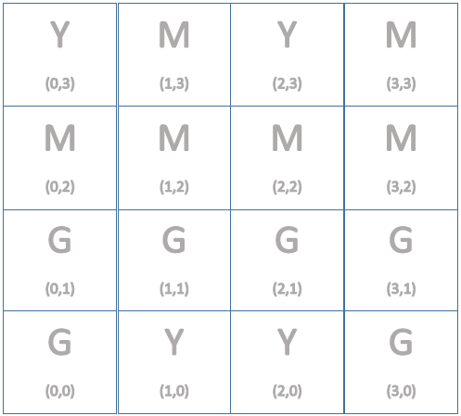

4 3 5 3

3 3 3 3

1 1 1 1

1 2 2 1

(b). How many connected components are in this graph?  
**There are 5 connected components.**

(c). Labeled above in part a.